Documentation

Shenesh Perera

IDM, Programming Unit #1 New Lanka Hospital

**BLANK PAGE**

Contents

Documentation 3

The Initial Screen(MDI) 4

Login Screen 4

Appointments Screen 5

Treatments Screen 6

Patient Registration Screen 7

User Registration Screen 8

Supply Stock Screen 9

Entity-Relationship Diagram 10

Class Diagram 11

Evidence of the usage of IDE 11

Features that made development easy 12

Test Plans 16

# Documentation

The IDE of my choice was the Visual Studio 2008. It contains the basic features every other IDE has like a code editor, debugger, builder, object explorer but goes a step forward and provides form design, code completion, data source connection, performance benchmarks and document organization.

During the process of developing the program for New Lanka Hospital, all these features were used thoroughly in order to obtain the maximum from the IDE and to ease my experience during development.

My choice of database engine was SQL Server 2012 by Microsoft, which comes with a management studio that allows developers to effectively create, maintain and secure databases, create tables, connections and also contains a query builder and a runner that runs SQL queries on tables.

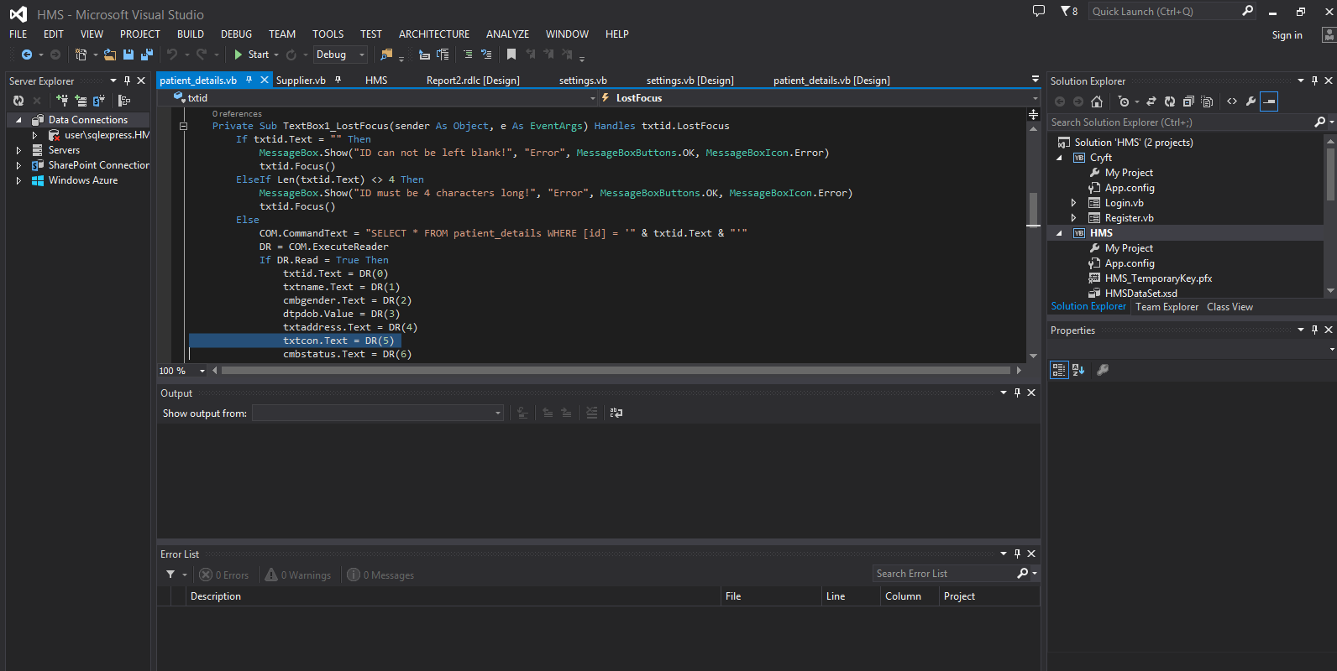

*Figure 1.0, Shenesh Perera, Sept 23rd 2018*

As seen above in figure 1.0, the initial screen by itself is welcoming and does not seem complicated to use. Getting started with your project is extremely easy.

# 

# The Main Screen(MDI)

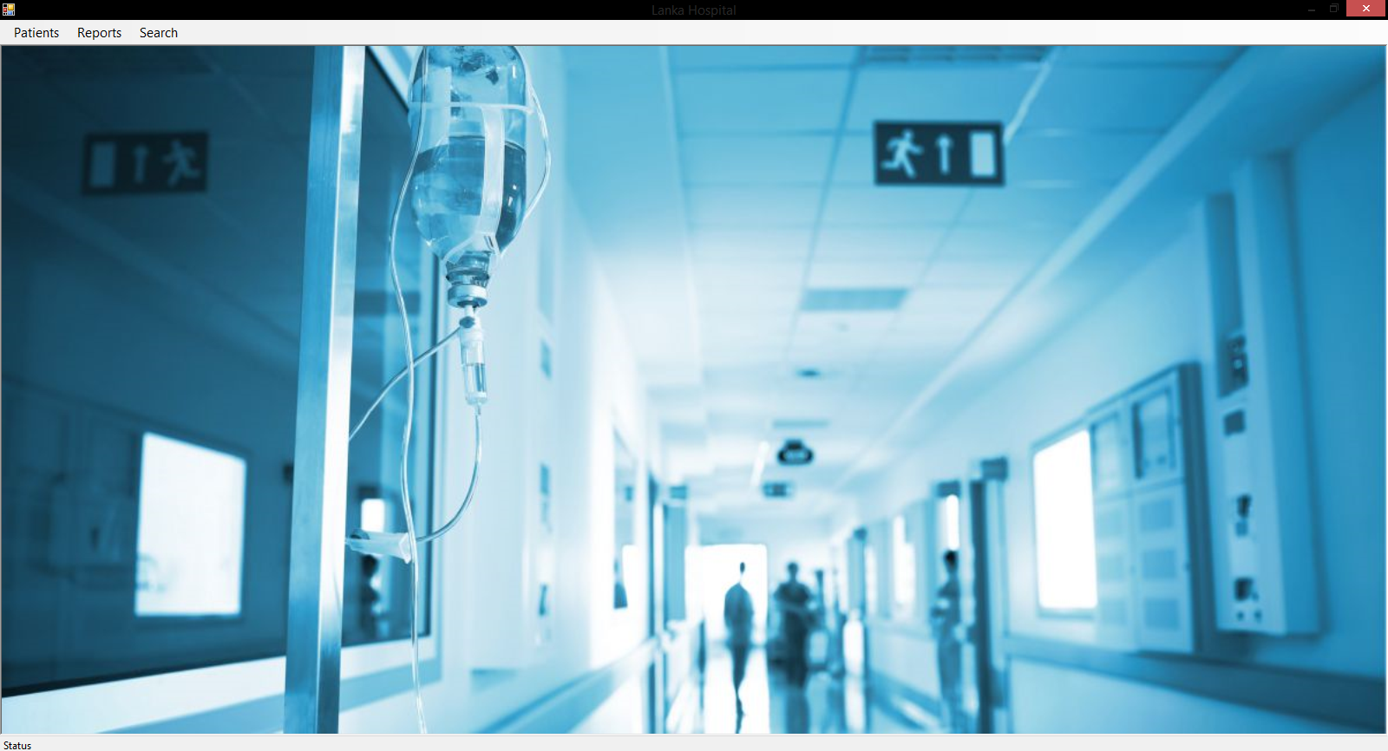

*Figure 1.1, Shenesh Perera, Sept 23rd 2018*

This is the screen that will be shown when the application has been provided with necessary credentials, you will be prompted with 3 menu options.

Each category has limited access depending on the rank of the logged in user. If it’s a nurse, as they serve at the administration rank, they will see all the submenu options available, including sorting and searching methods. For doctors however only the patients, reports and search categories will be displayed.

# 

# Login Screen

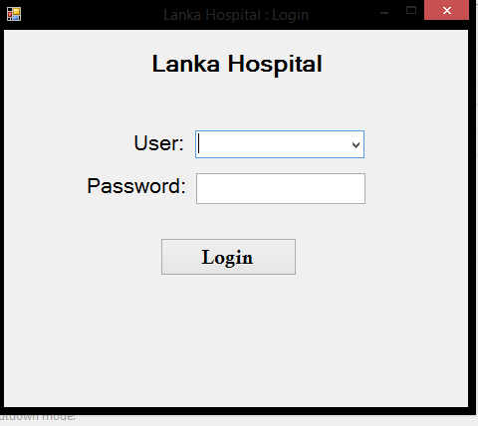

*Figure 1.2, Shenesh Perera, Sept 23rd 2018*

Before the initial screen is displayed, a login will be prompted. You must select the user type from between doctor and nurse, the password for doctors are @lanka#doctor18 while for nurses it is @lanka#nurse18.

Users that login with each rank respectively will be given the appropriate permissions, the settings screen allows you to change the password for both user types, this feature is restricted to nurses.

# Login Screen Code

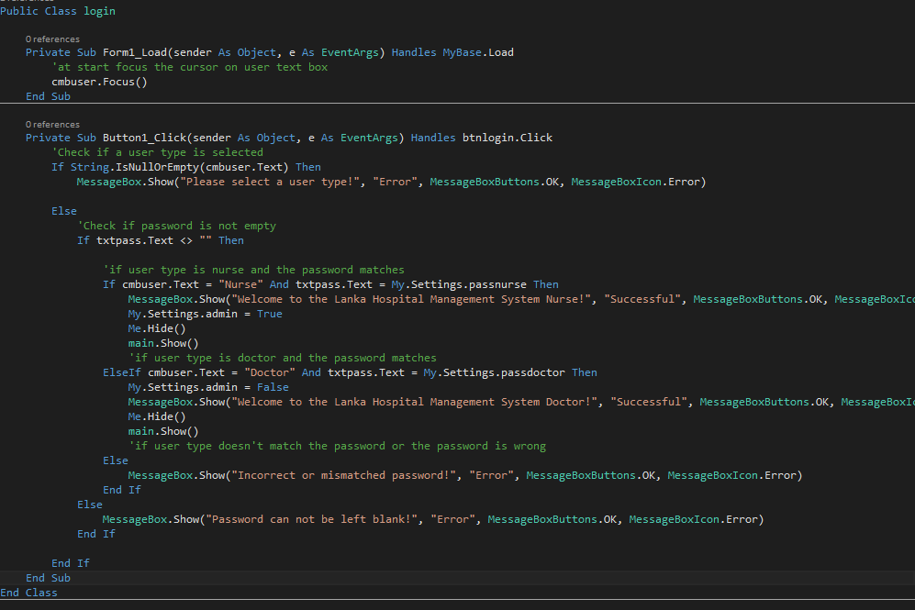

Code figure 1.0, Shenesh Perera, *Sept 23rd 2018*

# 

# Patient Registration Screen

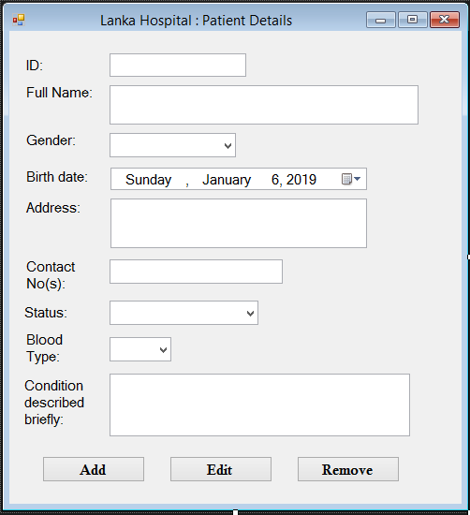

*Figure 1.2, Shenesh Perera, 23rd September 2018*

The patient registration interface is provided to nurses in order to maintain patient records, patient records can be updated and deleted as well. All registered patients are added to a database, and then nurses are alerted to either set an appointment for them or provide treatments. If you wish to check the details of any patient available, type the id of the patient and press tab on your keyboard, the details will be automatically filled. If a patient does not exist, details will not be displayed.

Patient details **must** be entered on the date of the appointment, as when you add patient details, the current date is stored as the date of the appointment. After the details have been inserted, nurses or doctors must immediately proceed to treatments. This is done using Visual Studio’s Application Setting interface using a list of objects that hold the id of the patient as the id and the date & time as the value.

I believe by doing this I will be cutting an unnecessary requirement for user, thus eliminating the need to waste time filling forms on appointments, since the program automatically does it for the user.

# Patient Details Code

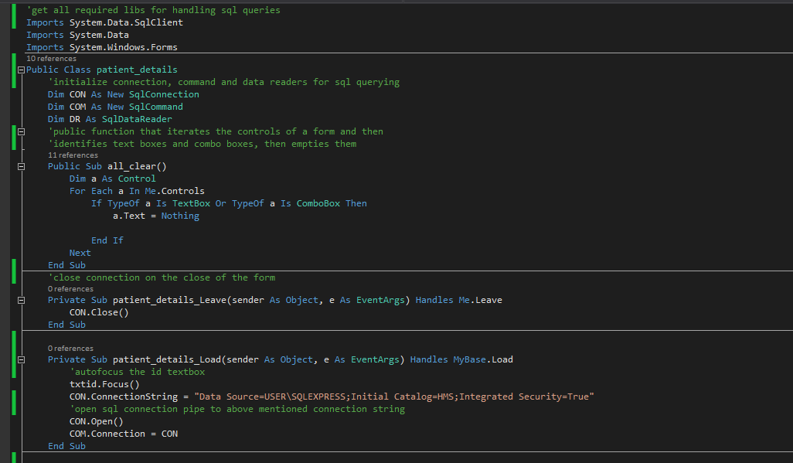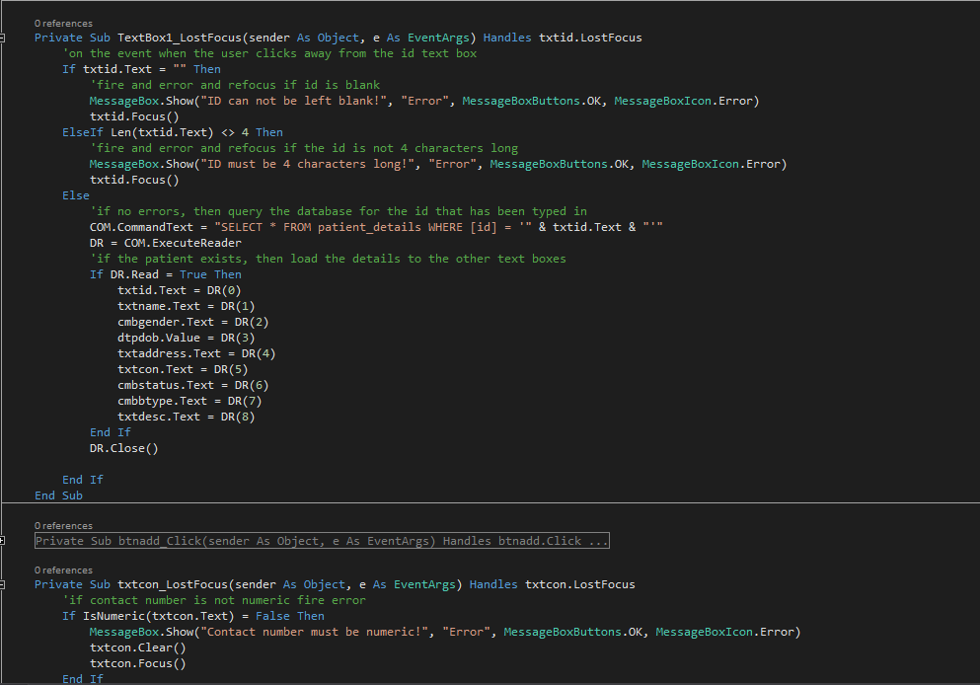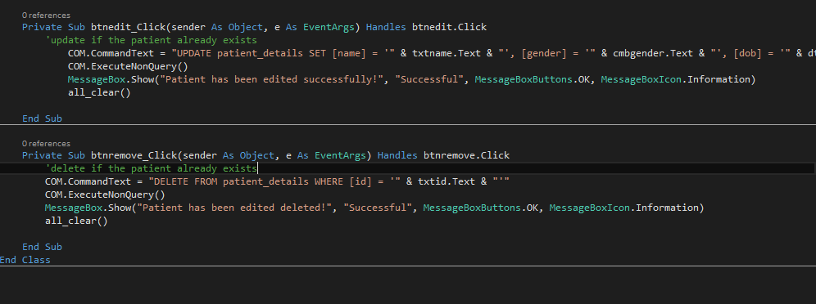

Code figure 1.2, Shenesh Perera, 23rd September 2018

# 

# Patient payments screen

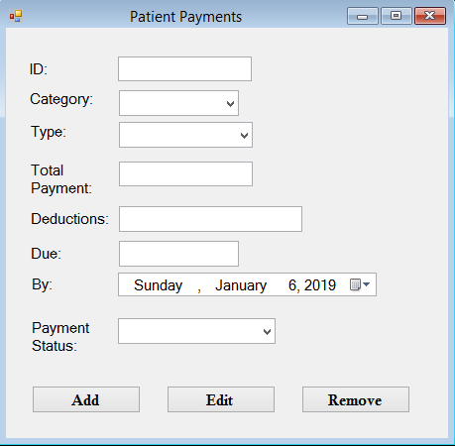

*Figure 1.3, Shenesh Perera, 23rd September 2018*

The patient payments screen consists of all the necessary controls to maintain the payments of a particular patient, **which has already been inserted to the database**. If a particular patient has not been inserted to the database, then you will not be able to register payments for that patient. Patient payments come in 2 categories, New and Regular with each having their type of payment to choose between Daily or Monthly, to facilitate daily payments more there is a deductions control.

Once the total payment and deductions have been inserted, the due amount will be automatically calculated. After which the payment status has to be set to Complete or Incomplete depending on the due amount.

# Patient payment code

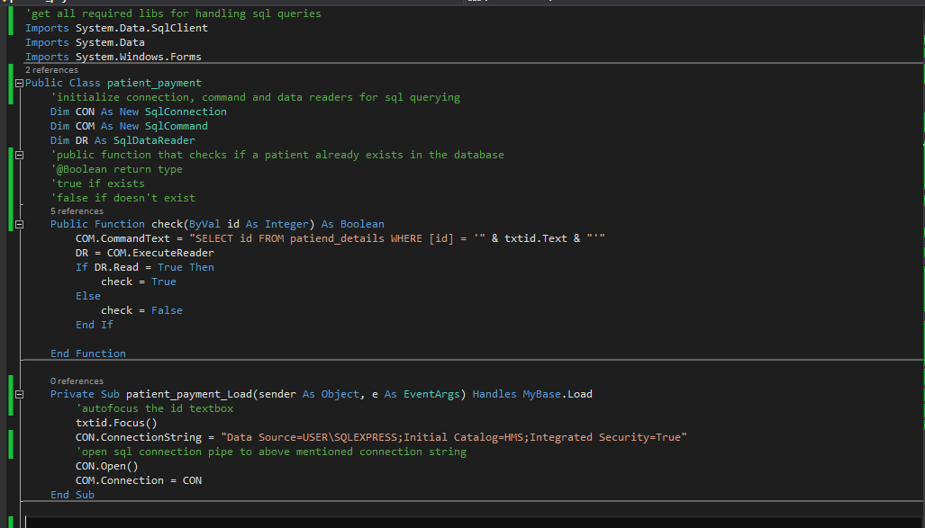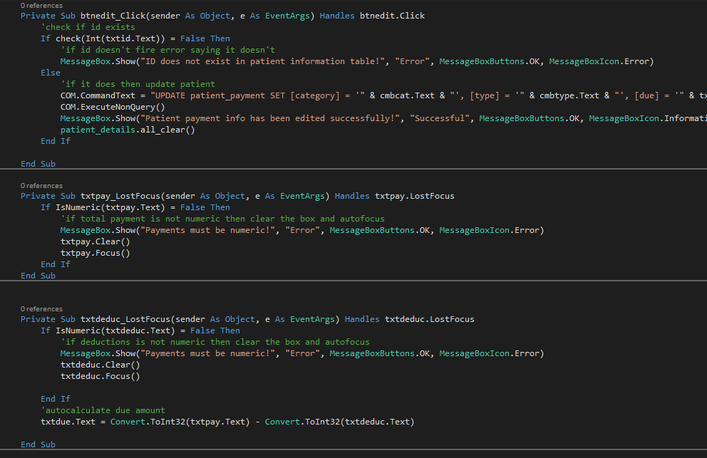

# 

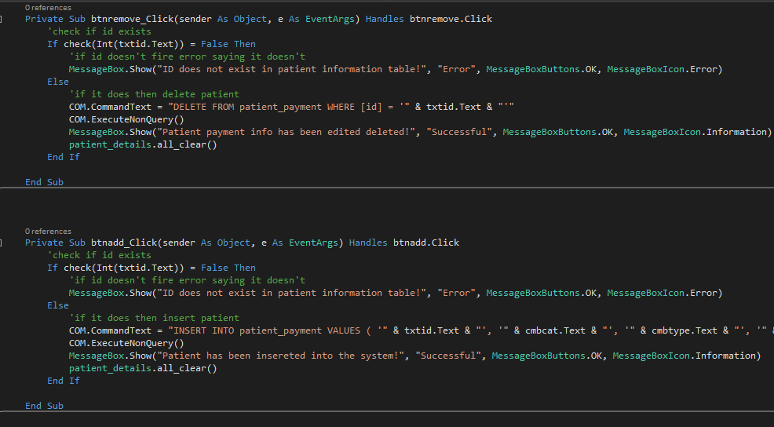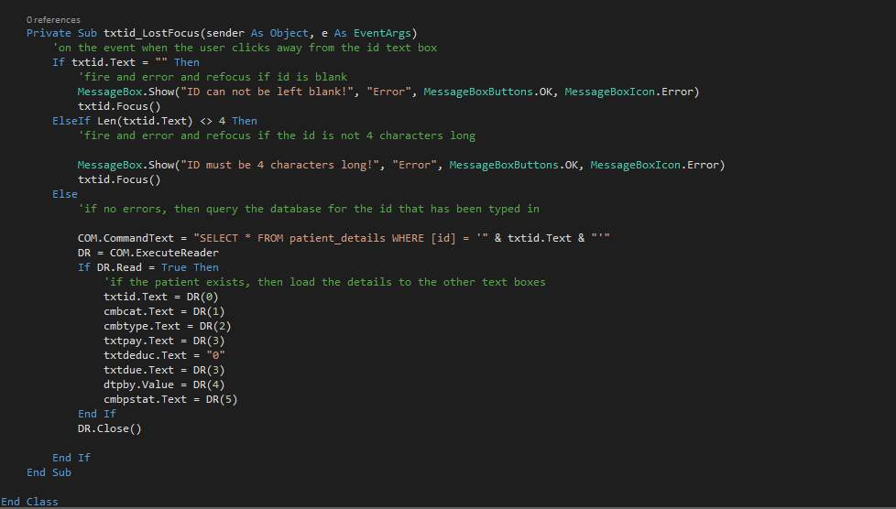

Code figure 1.3, Shenesh Perera, September 23rd 2018

# Supply Stock Screen

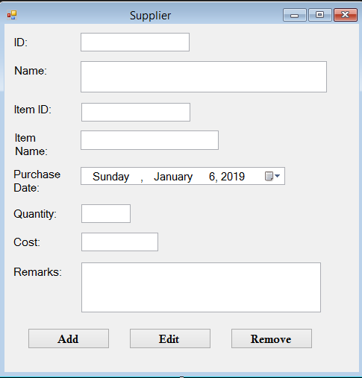

*Figure 1.4, Shenesh Perera, 23rd September 2018*

This interface can only be reached by nurses.

In this interface all supplies available within the hospital can be maintain, it is ideal for Lanka Hospital to request for unique ids for items they purchase so that this interface can be used to its fullest potential, however the nurses are responsible for assigning a unique id to the supplier.

By giving an item a unique id, it will be easier for a nurse to identify the object however as this is not an enforced feature, the program will not reject duplicate item IDs. However, I highly insist that this suggestion is put to effect.

# Supplier code

Code figure 1.4, Shenesh Perera, Sepetember 23rd 2018

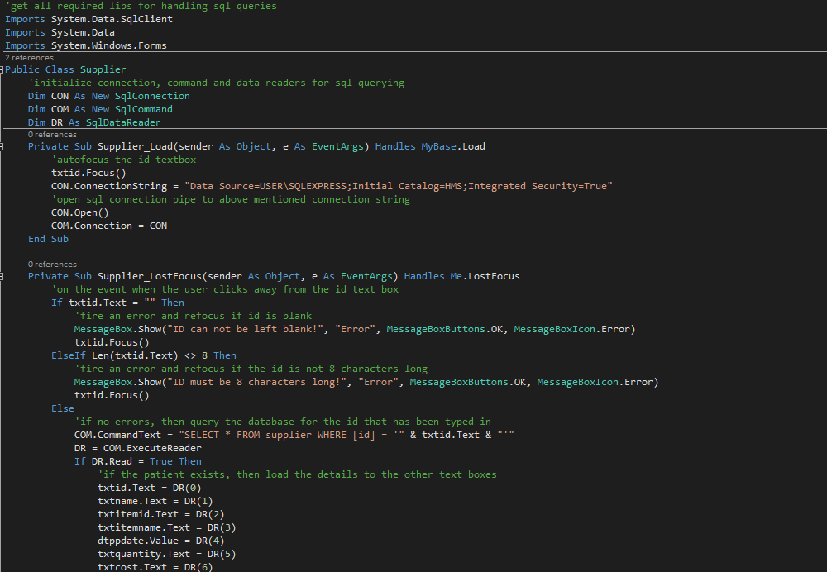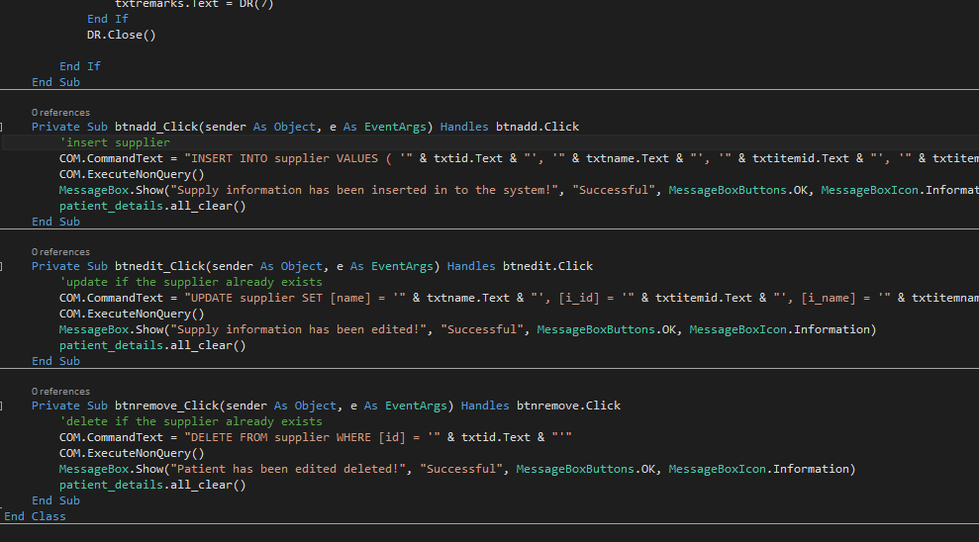

**LEFT BLANK INTENTIONALLY**

# Settings Screen

# *C:\Users\PC\AppData\Local\Microsoft\Windows\INetCache\Content.Word\19.png*

*Figure 1.5, Shenesh Perera, 23rd September 2018*

This interface is also for nurses only.

You must be logged in as a nurse to access this interface even to change the password of doctors. After the current password has been inputted, then the new password should be inputted and confirmed.

Passwords cannot be viewed at any point in this application due to high security enforcements.

Passwords are stored in Visual Studio’s Application Settings storage, after a thorough Triple DES 168 key type with a 8 character alphanumeric randomly generated key, the key is generated each time the application opens and the 2 passwords are freshly encrypted with a new key each time the application opens. This way security is highly administered, I highly recommend nurses to change the default passwords.

All the code that is responsible for the encryption have been securely obfuscated within the program and cannot be accessed.

However to facilitate the comprehension of the implementation, I will show my code that I have used to **implement the algorithm.**

The Triple DES algorithm implementation is stored in a different secure form and imported separately to a temporarily generated XML file that is used to handle the encryption and then supplied to the designer form of the settings form.





Code figure 1.5, Shenesh Perera, September 23rd 2018

# Settings code

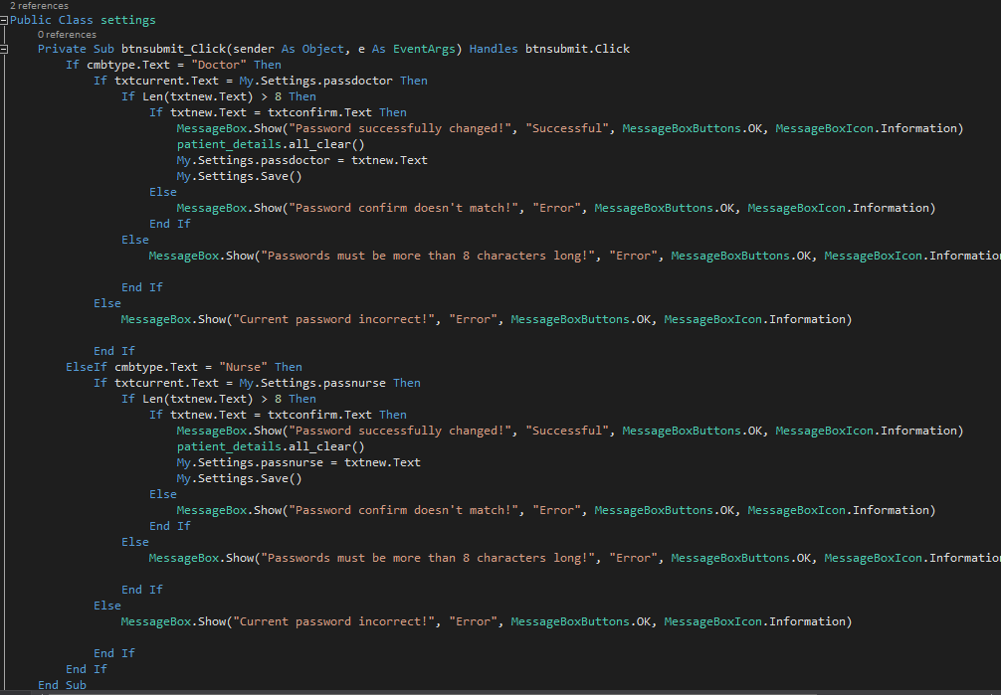

Code figure 1.6, Shenesh Perera, 23rd Sepetember 2018

Default passwords:

Doctors: @lanka#doctor18

Nurses: @lanka#nurse18

These passwords actually violate the application enforcement of having 8 character passwords, this has been done in order to demonstrate what a strong password is and to deliver the product with the highest security standards.

# Entity-Relationship Diagram

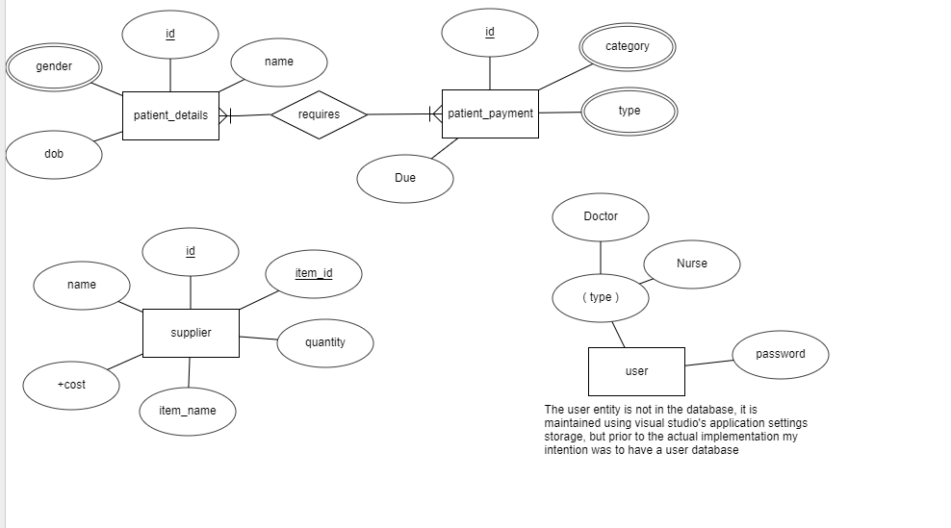

Figure 1.6, Shenesh Perera, September 14th 2018

# Class Diagram

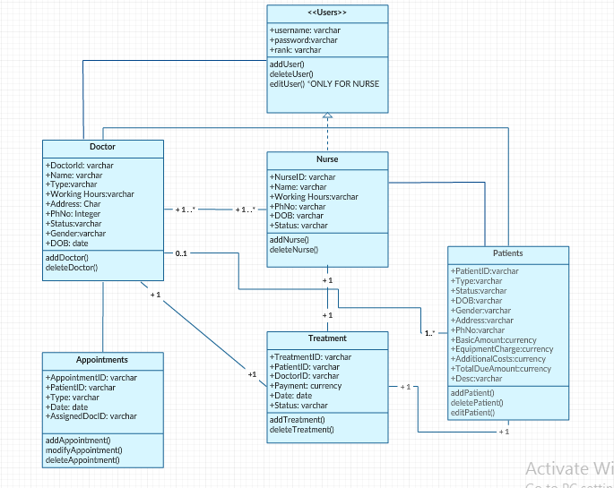

Figure 1.7, Shenesh Perera, September 14th 2018

# Evidence of the usage of IDE

Figure 1.8 & 1.9, Shenesh Perera, September 23rd 2018

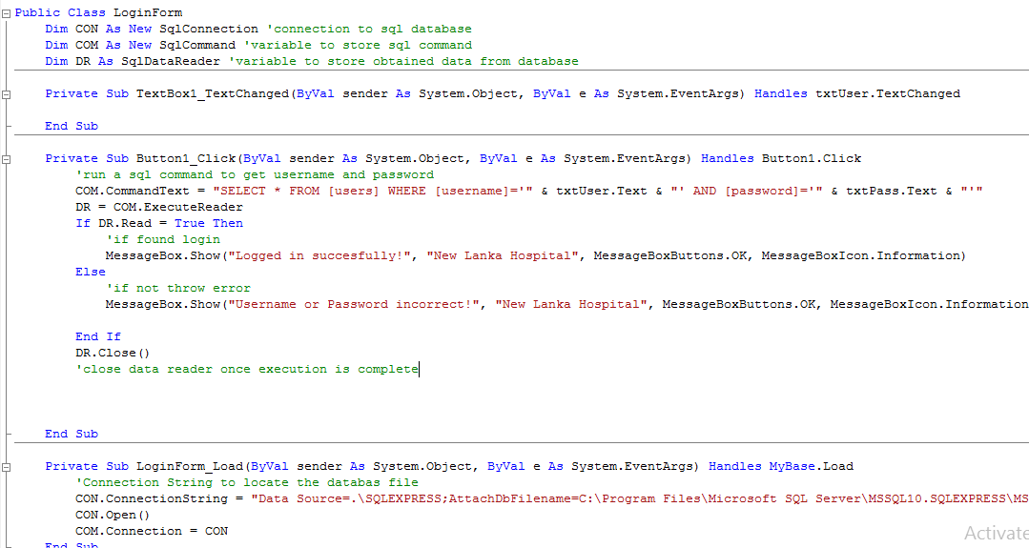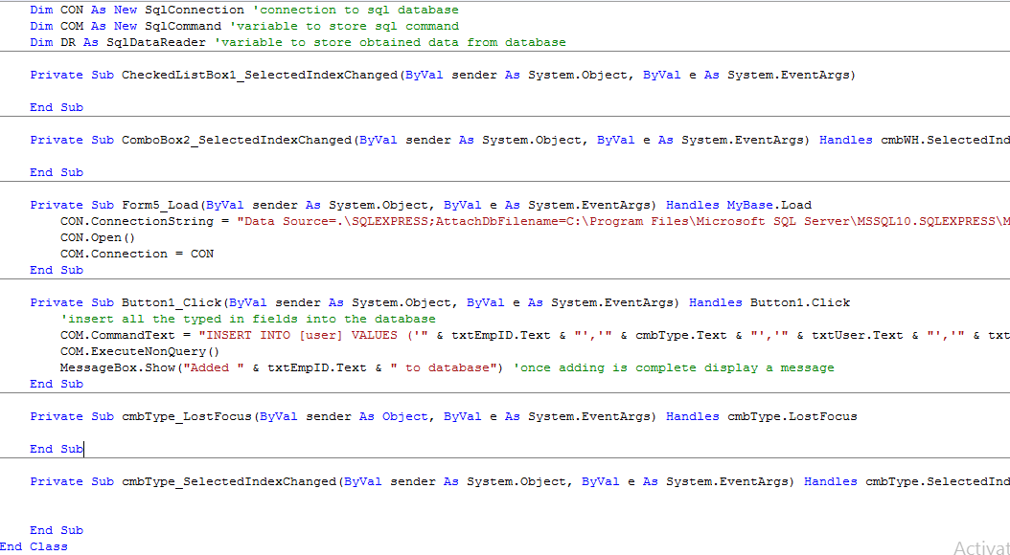

# Features that made development easy

Commenting

Figure 2.0, Shenesh Perera, September 23rd 2018



Commenting allows for getting used to the codebase and briefly explaining any code block without the programming language’s concepts, in such a way any reader can understand.

Intelligent code-completion

This context-aware feature is built into the IDE to allow developers to code faster and more accurately. In case a developer forgets a particular method, he could type the first few letters of the method and the toolbox will appear above it to choose from the variety of methods available with those characters.

This feature allowed me to code faster and explore multiple other methods that help achieve the same purpose.

Menubars with multiple functions

Figure 2.1, Shenesh Perera, September 23rd 2018



As seen here, the menu bars provide a variety of helpful tools that help a developer. Notably the debug, data and project menus were imperative during development since they provide 3 most crucial features. Debug menu contains features for debugging code, the data menu contains features to connect databases while the project menu had features to alter the project structure, adding new forms and editing the project propertie

Toolboxes with a net of interfaces

Figure 2.2 & 2.3, Shenesh Perera, September 23rd 2018

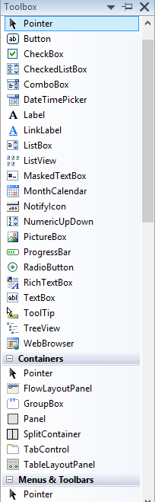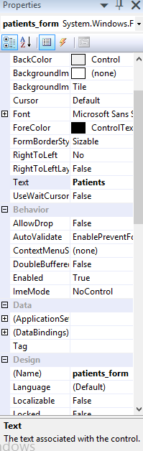

Toolboxes like these provide access to numerous interfaces that can help development and provide shortcuts to many things that would otherwise be done with a lot of hassle.

As you see, the left side toolbox has a lot of tools that help form design and simplifies it.

While the right side toolbox provides a numerous tools that grants functionality to the form, the left side toolbox provides interfaces to organize and manipulate the tools taken from the right side’s toolbox.

Debugging

Figure 2.4, 2.5, Shenesh Perera, September 23rd 2018

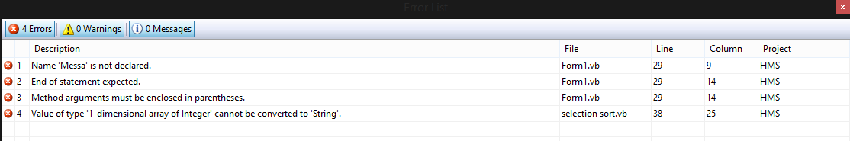

This is the process by which the IDE shows the developer what types of errors/bugs exist in the code that we’ve written.

Debugging is crucial, as bugs can be exploited in order to mutate the application to allow unauthorized access, data corruption or disintegration.

In this IDE in particular, the IDE doesn’t allow the developer to build, release or publish a software without ensuring that all bugs in the program have been dealt with.

Debuggers make sure that unexpected output doesn’t happen.

In the above picture, the debugger has been run and the error box is displayed. It includes information such as the line, column and the file and even the project the error is on. So the error can be located and dealt with, in ease.

Development without an IDE is therefore a huge risk, as a debugger may not be involved during the process of programming. This will eventually give rise to a heap of errors that is unknowingly pushed on, and then the program is built with a lot of errors that hackers and crackers can easily exploit.

Debugging plays a major role in every developer timeline, as such having a debugger in an IDE is a huge advantage.

An IDE shouldn’t allow the compilation or the building of a code base if it contains bugs or errors. Just by the name itself the function of a debugger is to de bug, or removes bugs.

Necessary interfaces being provided to implement algorithms

Figure 2.6, Shenesh Perera, September 23rd 2018

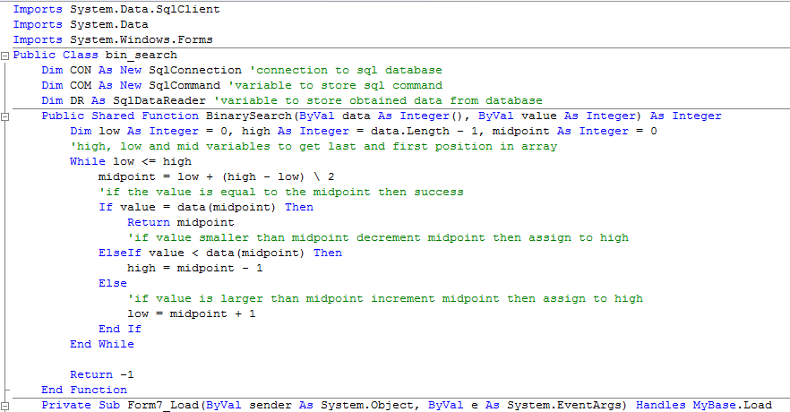

This is the implementation of Binary Search in the program, due to the existence of the debugger it was particularly easy to implement as you can debug every block of code when its run till the intended output is obtained.

Figure 2.7, Shenesh Perera, September 23rd 2018

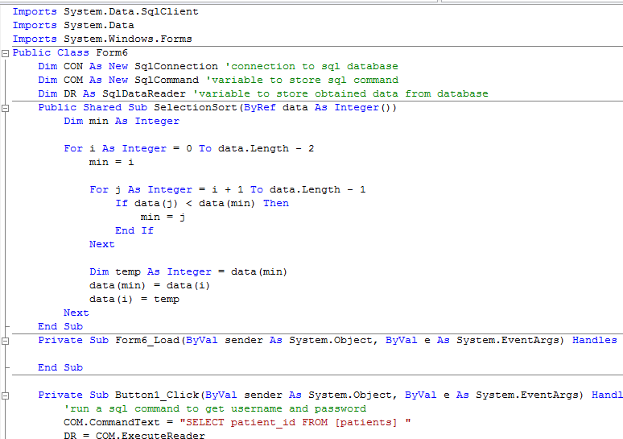

This is the implementation of Selection sort in the program that allows nurses to effectively search in the patient records.

**Database Normalization**

First Normal Form Test;

1. Ensured that there are only single valued rows and columns
2. All column names have been made unique
3. Ordered in ascending order

Hence New Lanka Database passed the 1NF test.

Second Normal form Test;

1. Database has been ensured and rechecked to see if it’s in the first normal form
2. All data has been checked for partial dependency and those that did, were removed.

Hence New Lanka Database has passed the 2NF test.

Third Normal form test;

1. 2NF test has been passed
2. Database consisted transitive dependencies, so 3NF test failed. In order to pass the test, all the data was checked, transitive dependencies were researched and then eliminated.

After fixes and compromise of some data, 3NF test was passed.

***Hence all tables in the database are normalized to 3rd normal form***